The Learning Trust
and
Christlelton High School
Significant Change Application
FAQ

Private & Confidential
June 2022

NB: To respect confidentiality of responses and feedback gathered through the Christleton High School consultation, some questions/feedback received has been merged and the wording adapted to ensure clarity.

- Will there be more students at Christlelton High School?
- No, the number of students at the school will remain largely unchanged (6th Form numbers can vary from year to year, appeals and students do occasionally leave and may not be replaced).
- The new build will allow us to move from a temporary Published Admission Number (the numbers we admit in year 7 every year) of 224 to a permanent Published Admission Number of 224. The school itself is not allowed to admit above its PAN.
- The school has been oversubscribed and runs at the temporary PAN number, leading to overcrowded spaces.
- This has led to our proposal which will allow us to solve the challenges brought about by our overcrowded teaching spaces.

- What is a Published Admission Number (PAN)?
- The published admission number or PAN is the number of pupils in each year group that the school has agreed will be admitted. This number is the maximum number that the school will be allowed to admit in that year group throughout their time in years 7 to 11.
- A temporary increase to the PAN can be sought by a school to accommodate for more children, especially in situations where there is high demand for a school roll.
- Christleton High School has been operating under a temporarily increased PAN of 224 since 2017.

- Why are you not increasing the PAN further than 224 to provide for even more children?
- Permanently increasing the PAN beyond 224 would require the agreement of the Local Authority and additional space in addition to the proposed building.
- It would require a major reshaping of internal corridors which could not currently safely accommodate a further increase in student numbers, and have an impact on traffic and the community.
- There are no plans to increase the PAN at this stage.

- Why are you not going back to a 208 PAN?
- Christlelton High School is a highly oversubscribed school partly due to the significant housing developments that have taken place in the catchment area. Reverting back to a 208 PAN would mean that there would be more disappointed parents who cannot access our school even when being within our catchment area.
- Reverting back to a 208 PAN would also have a financial impact on our school as we receive funding based on pupil numbers. This may not allow us to provide the same high standard of education that our children deserve because a significant portion of our funding allocation is invested into ensuring our students are provided with their current quality of education.

- Will this lead to increased traffic in the village?
- This should not have any impact on traffic, as there will be no increase in pupil numbers, the administrative change to PAN will not affect the actual number of pupils attending Christleton High School, which will remain largely the same as they are now.

- Will the development include provision for pupils/staff with mobility issues?
- Lift access is already in place on the upper art corridor, some 10m away from the entrance to the first floor of the new build, disabled toilets are also planned in the new block.

- Will the proposed extension be enough to address current facility shortfall?
- This proposal has been designed to address the physical constraints of the site resulting from the school operating under a temporarily increased PAN to best meet the needs of the community the school serves.
- An analysis of the current facilities and buildings against student roll and curriculum option requirements was undertaken by E3 Cube which led to this proposal design.
- At the same time, we have already carried out a number of internal space remodelling projects within the current fabric of the buildings.

- How will you ensure to minimise the building noises to avoid impacting on children’s education, as well as the surrounding community?
- As a considerate member of the local community, we will do everything we can to minimise construction noises and any indirect impact on the community.
- In appointing a contractor, we will work with the construction company to agree on building hours which are best for students and the neighbourhood, whilst ensuring we minimise the build time.
- We will best manage materials drop-offs and seek to avoid peak traffic hours as much as possible.

- Where exactly will the building be located on the school site?
- The building will be located next to art building, occupying the currently unused outside field.
- Below is a survey aerial plan of where the building will be located. Further details accessible here.

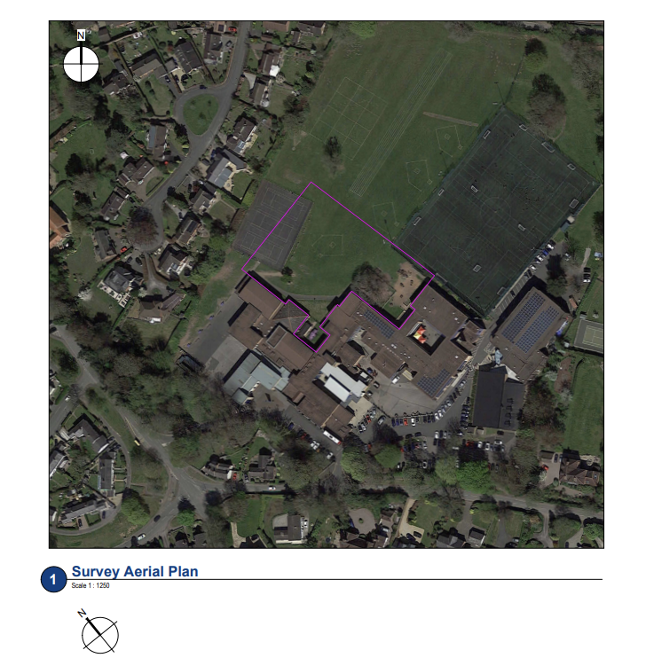

- Could you provide plans of how the interior of the building will be arranged?
- Building plans are accessible on our consultation webpage here.
- The proposed arrangements for the ground floor and first floor is outlined below.
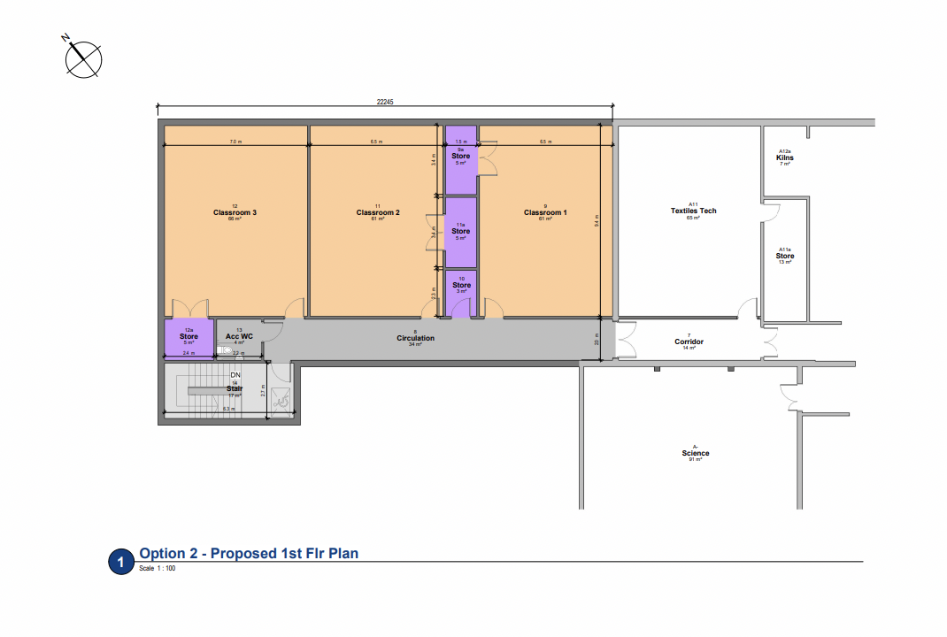
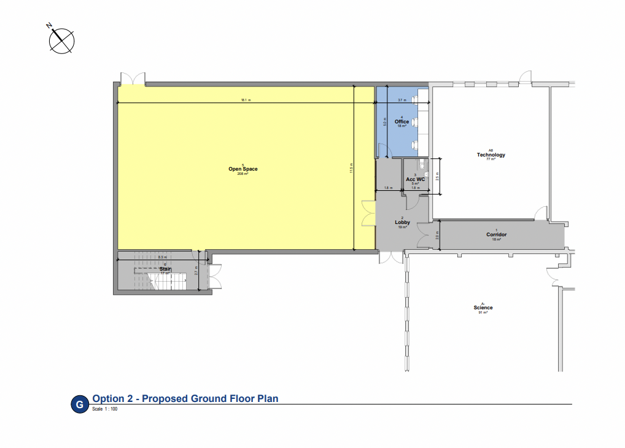

- Will you be removing trees?
- We will not be removing any trees – Tree Preservation Orders (TOP) remain in place on both trees in the near vicinity of the new build, they are treasured landmarks for the school
- The old chestnut tree appears on school cards, there is no plans to remove it.

- Will there be any knock-on effects to village?
- There will be minimal disruption to the village.
- The number of children will remain unchanged, therefore no impact on traffic or on the other education settings around.

- Will the study and social areas be depleting in size, making it a less attractive space?
- The proposed change will provide for more space and improvement of existing space through refurbishment, therefore making it more suitable for children and their education.

- Has a curriculum analysis been undertaken to evaluate current provision?
- Yes, we know which departments are in need of re-housing and the way our curriculum has developed in recent years, means that we need more smaller rooms for interventions, but also more rooms that can accommodate class sizes of 30+ in those areas that set – English and Maths.
- Once the build is complete, there will be some minor changes to internal configurations around the current sixth form common room.

- It would be good to see some maintenance of the facilities you already have got. What is happening with the cladding for example?
- We pride ourselves in maintaining our buildings
- The current issues we have with cladding is currently subject to legal action and will be repaired as soon as possible

- Pupils deserve a few settled years without any unnecessary change to their Sixth form area so they can study and feel at ease. Building work will disrupt learning greatly if it is done during term time. This year group particularly has suffered with Covid disruption and needs stability.
- We are well aware of the impacts of Covid on our students and are working hard to support our students through the challenges created.
- We will work hard to minimise the impact of the building work on the normal operation of the school day
- There will be no impact on current study or classroom space from the build as it is external to the current building.

- It is vital that either numbers are expanded or that catchment areas are reviewed as the huge housing development in Huntington/Saighton results in less opportunities to attend from local rural villages which has Christleton as the nearest high school. The Huntington/Saighton estate has Bishops High School in the local area so surely with two high schools the catchments for Christleton should be reviewed. It makes no sense that children in Hargrave would be expected to get to Bishop Heber in Malpas at over 13 miles away each way, whereas Christleton is 4 miles down the road, on a bus route and children attend feeder school of Waverton. I would appreciate a catchment area review of Christleton to take these points into consideration.
- The decision to allow building at Saighton camp was accompanied by extra funding for both primary school (Huntington) and secondary. That funding was used to build new premises at Bishops Blue Coat and to fund this block at Christleton
- There are no plans to review CHS catchment area at this stage.

