Christleton High School



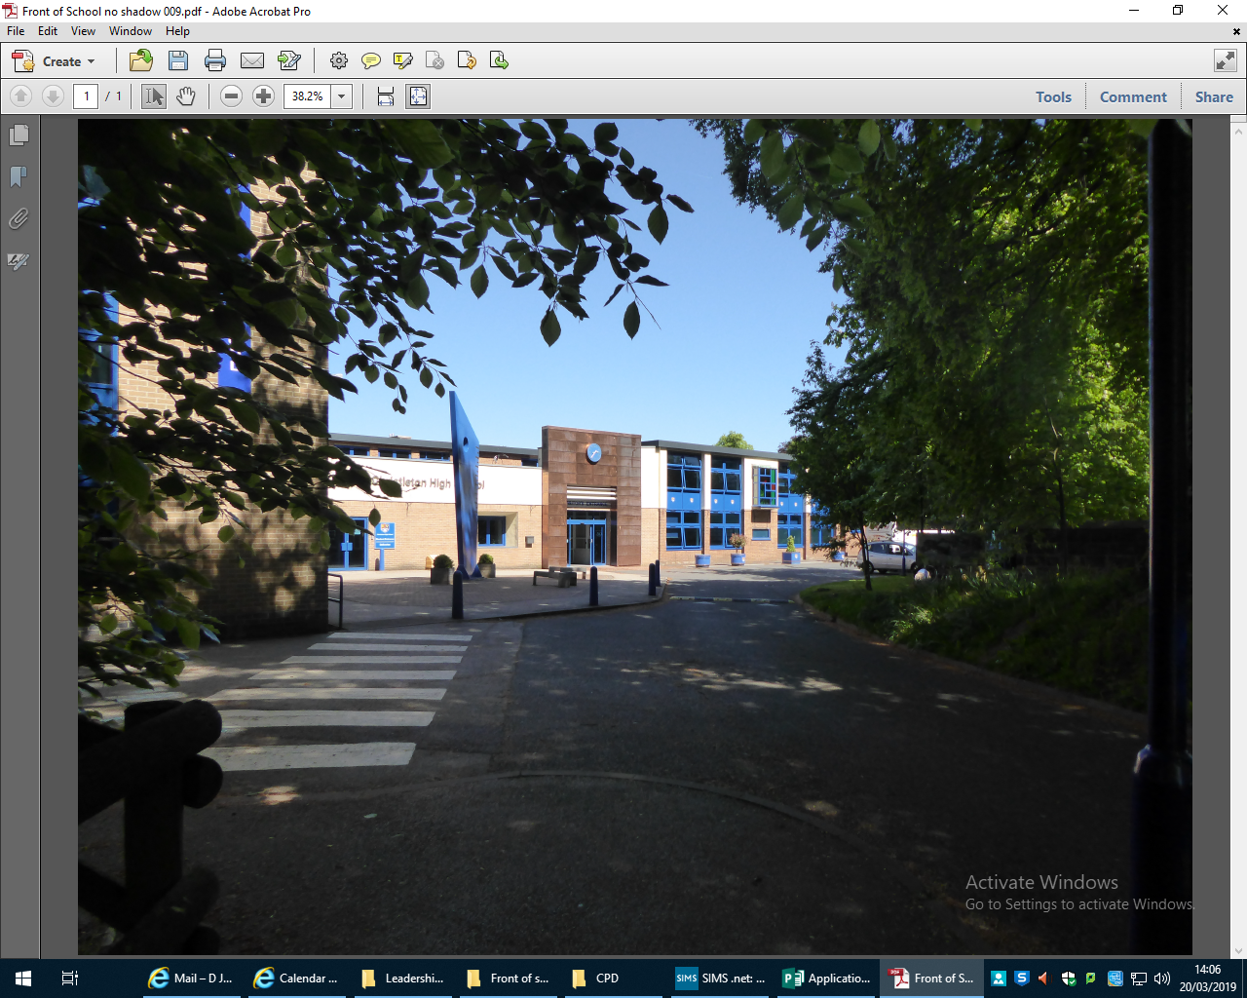

September 2020 opening

Guidance booklet

for

Key Stage Four students

and

parents/carers

Dear Parents/Carers

I am writing to you to outline our plans for the full opening of school in September.

As I have stated in a recent communication, the government has now published its guidance concerning wider opening. Whilst this places fewer restrictions on us, than anticipated – for example, they have removed the need for social distancing that is still in operation in wider society; what they have left in place: that Year groups/bubbles should, where possible, not mix – has left us with a logistical conundrum!

This letter outlines our plans for Key Stage Four students and other information regarding the return to school after the summer break – I apologise in advance for its length and detail!

Year 10 and Year 11 will commence the new school year on Thursday 3rd September at 08:50.

**Health and Safety**

Our primary concern is to keep everyone safe. The virus is still in circulation in our community and all our plans are to mitigate the risks involved in having over 1400 students and 120 staff in the same building.

* There are hand sanitiser stations at every entrance and located on most corridors and all communal areas around the school. Students will be asked to wash hands or use the sanitisers as frequently as possible.
* All students are encouraged to bring their own personal hand sanitiser.
* The issue of face masks is a controversial one, with conflicting advice from scientists. If students wish to use them, they can, however, we are not in a position to supply them. We would urge all parents/carers to discuss this matter with their children and educate them on the correct way to wear [a mask] and should they wish remove it, how to store it safely during the day. The following link offers some advice on making masks and on basic safety instructions:

<https://www.gov.uk/government/publications/how-to-wear-and-make-a-cloth-face-covering/how-to-wear-and-make-a-cloth-face-covering>

<https://www.london.gov.uk/coronavirus/face-covering-guidance>

<https://www.youtube.com/watch?v=SfZmWJOUEh0>

* In order to control the flow of students around school, we have initiated a one-way system in certain areas and these are to be adhered to at all times.
* All water fountains will be disconnected and students should bring in their own drinks and snacks.
* Toilets will need to be shared between different Year group bubbles, but these will be cleaned on a regular basis.
* All classrooms will have desks arranged in forward facing rows.
* Staff will maintain a minimum 1m distance from students in all classrooms at all times.
* We have our own cleaning team on duty throughout the day and there will be frequent cleaning of the site.
* Each Year group bubble will have its own social area and these must be adhered to at all times, students should not wander into the social areas of other Year bubbles.
* When Year group bubbles need to use communal areas – eg canteen – these will be cleaned between change-overs.
* Staff will enforce the “catch it, bin it, kill it” message.
* Because KS3 students are in their own dedicated zone and remaining in the same classroom for all their lessons, corridors will be significantly less busy. However, we do expect all students to follow the restrictions that are in place, for example, keeping to the left in corridors, keeping appropriate distances from each other and obeying No Entry and One-Way systems.

**Timings of the school day** – in order to keep Year groups apart as far as possible, it is necessary to stagger the start and finish times of the school day, as well as break and lunch times. Therefore, as a **temporary** measure, the school day for Key Stage Four students will be as follows:

|  |  |
| --- | --- |
| **Timings** | **KS4** |
| **08:50-09:00** | Arrival on site |
| **09:00-10:00** | Period 1 |
| **10:00-11:00** | Period 2 |
| **11:00-11:20** | Break |
| **11:20-12.20** | Period 3 |
| **12:20-13:20** | Period 4 |
| **13:20-14:00** | Lunch |
| **14:00-15:00** | Period 5 |
| **15:00-15:20** | Tutor |

Wednesdays will continue to finish early, and for KS4 students this will be at **14:10** following a shortened Tutor period.

Year 10 and 11 students should arrive at school via the Plough Lane entrance. Depending on what time they actually arrive on site, they can either wait in the senior yard, suitably socially distanced, or go straight to their first lesson.

Any student who arrives late to school, after the gates and entrances have been locked, must report to the student entrance next to the blue monument.

Key Stage Three and Sixth Form students will have a different start and finish time. Those KS4 students who travel home with older or younger siblings will have to wait in the senior yard or in wet weather, in the school Hall, until such time as they can leave together.

At break time:

Year 10 – junior yard and tennis courts

Year 11 – 4G astro pitch and adjacent picnic area

If wet weather

Year 10 – school Hall

Year 11 – main canteen

No contact sports can be played at either break or lunchtimes.

We expect students to stay in their own social area during these times and not encroach on the areas of other Year bubbles.

Unfortunately, due to the restrictions of the guidance on Year group bubbles, we will be unable to offer canteen facilities at break time and student should bring their own snacks and drinks.

At lunchtime – we will be using the Sixth Form common room and canteen as well as the main school canteen. The canteen will be operating a reduced service and we request that if possible, students bring their own packed lunches. Free School meals will still be provided by school, but a reduced service will be in operation.

Lunchtime arrangements:

|  |  |  |  |  |  |
| --- | --- | --- | --- | --- | --- |
| Year | Monday | Tuesday | Wednesday | Thursday | Friday |
| 10 | Sixth form common room for sandwich ‘grab-bag’ provision.  Junior yard/tennis courts | Hot food canteen.  Junior yard/tennis courts | Sixth form common room for sandwich ‘grab-bag’ provision.  Junior yard/tennis courts | Hot food canteen.  Junior yard/tennis courts | Sixth form common room for sandwich ‘grab-bag’ provision.  Junior yard/tennis courts |
| 11 | Hot food canteen.  4G and picnic area | Sixth form common room for sandwich ‘grab-bag’ provision.  4G/picnic area | Hot food canteen.  4G and picnic area | Sixth form common room for sandwich ‘grab-bag’ provision.  4G/picnic area | Hot food canteen, 4G and picnic area |

Students will be able to order their ‘grab-bag’ food for a week at a time via Edulink. These may be eaten in any of the designated areas.

Students who bring their own packed lunch may eat them in any of the designated areas.

Hot food menus will vary and these can be paid for daily in the usual way, with appropriate hygiene protocols.

**Curriculum**

Key Stage Four students will be following their full GCSE curriculum as planned. For Year 11 this will mean having the teachers they had last year and continuing their programme of study. Year 10 students have already been informed of their new GCSE option choices and commence their two-year programme as planned. Due to the zoning of KS3 students, some lessons may not necessarily be in normal subject rooms, but we have ensured that all specialist rooms, eg Science labs, Art rooms, DT rooms etc are fully available for GCSE students.

**Uniform**

During these temporary arrangements, students will continue to wear full uniform.

**PE**

On the days students have PE, they can attend school in either their PE kit or school uniform (including trainers) – this will remove the need to use changing rooms. As the weather gets colder, appropriate outer clothing should also be worn. PE lessons will be taking place outside, unless there is adverse weather, in which case the school gym and sports hall will be used. The PE curriculum provisions will be changed to avoid all contact sports. There will be no school fixtures for any of our team sports until we are cleared to do so. Every Year bubble will have its own dedicated sets of equipment and there is a strict hygiene protocol for PE equipment, which will be explained to students at the start of every lesson.

**Performing Arts**

Extra-Curricular Performing Arts activities including Drama Clubs, School Music Groups, Concerts and Shows will not take place during the Autumn and Spring terms. One to one music lessons may still be able to take place in some format and Mr Phillips will make contact with parents separately about this.

**Equipment**

Students must come prepared to learn and this means bringing all their own equipment in terms of pens, pencils, rubbers, rulers, calculators etc. No stationery or equipment will be lent out.

**Trips**

There are no school trips planned for the Autumn and Spring terms.

**Assemblies**

There will be no Year group assemblies for the foreseeable future. Senior leaders and Heads of Year, will deliver assemblies via remote platforms

**Mobile ‘phones**

Our mobile ‘phone policy has not changed. Mobile ‘phones are not to be used or seen anywhere in the school building unless authorised by a member of staff.

**Assessment and Reporting**

Our assessment and reporting framework will run as normal – this means tests, mock exams and interim and final reports will remain in place. There will be some amendments to the timing of some of these and all key dates are accessible from the school website. During the Autumn term, teachers will be assessing all students to enable them to find out where each student is in terms of knowledge and understanding of the key elements of each subject. This will allow staff to put in place appropriate support programmes for each student. The recovery of lost learn will be a long-term process – it’s not something that can or will be completed in one term. Staff will plan the recovery curriculum based on the outcome of regular assessments and tailor provision accordingly. Further adjustments to our curriculum and processes will be considered if they prove necessary, for example, extending the school day, catch-up classes, the use of support tutors etc. These decisions will be made based on the judgements of class teachers and will be different for each student.

It is also clear that Parents’ Evenings, will not be able to run as they have in the past. We will inform you of the new format in due course.

**Attendance**

The government have made it clear that they expect all students to return to school in September.

Shielding advice for all adults and children will pause on 1 August, subject to a continued decline in the rates of community transmission of coronavirus (COVID-19). This means that even the small number of pupils who will remain on the shielded patient list can also return to school, as can those who have family members who are shielding.

There will however, be a small number of students who will still be unable to attend in line with public health advice. Heads of Year will contact these families to arrange continued home learning.

Families will still need to minimise contact with individuals who are unwell by ensuring that those who have coronavirus (COVID-19) symptoms, or who have someone in their household who does, do not attend school.

**Engage with the NHS Test and Trace process**

Together, school and parents must ensure that we understand the NHS Test and Trace process and how to contact our local Public Health England health protection team. Parents/carers will need to be ready and willing to:

* book a test if they are displaying symptoms. Students must not come into the school if they have symptoms, and will be sent home to self-isolate if they develop them in school.
* provide details of anyone they have been in close contact with if they were to test positive for coronavirus (COVID-19) or if asked by NHS Test & Trace
* self-isolate if they have been in close contact with someone who develops coronavirus (COVID-19) symptoms or someone who tests positive for coronavirus (COVID-19)

Anyone who displays symptoms of coronavirus (COVID-19) can and should get a test. Tests can be booked online through the NHS testing and tracing for coronavirus website, or ordered by telephone via NHS 119 for those without access to the internet. Essential workers, which includes anyone involved in education or childcare, have priority access to testing.

Trace and Track website:

https://www.nhs.uk/conditions/coronavirus-covid-19/testing-and-tracing/nhs-test-and-trace-if-youve-been-in-contact-with-a-person-who-has-coronavirus/

We ask you to inform us immediately of the results of a test:

* if someone tests negative, if they feel well and no longer have symptoms similar to coronavirus (COVID-19), they can stop self-isolating. They could still have another virus, such as a cold or flu – in which case it is still best to avoid contact with other people until they are better. Other members of their household can stop self-isolating.
* if someone tests positive, they should follow the ‘stay at home: guidance for households with possible or confirmed coronavirus (COVID-19) infection’ and must continue to self-isolate for at least 7 days from the onset of their symptoms and then return to school only if they do not have symptoms other than a cough or loss of sense of smell/taste. This is because a cough or anosmia can last for several weeks once the infection has gone. The 7-day period starts from the day when they first became ill. If they still have a high temperature, they should keep self-isolating until their temperature returns to normal. Other members of their household should continue self-isolating for the full 14 days.

In the event of a local outbreak, the PHE health protection team or local authority may advise us to close temporarily to help control transmission. We have a contingency plan for this eventuality. This may involve a return to remaining open only for vulnerable children and the children of critical workers, and providing remote education for all other students.

**Behaviour**

We acknowledge that some students will return to school having been exposed to a range of adversity and trauma including bereavement, anxiety and in some cases increased welfare and safeguarding risks. This may lead to an increase in social, emotional and mental health concerns for some young people. Staff have received training on how to help students cope with the anxiety they may feel when returning to school and we know that a degree of readjustment is needed.

We have very clear behaviour expectations and will continue to uphold the standards that you expect of us. Any student who willfully flouts the health and safety processes that have been put in place, or who threatens the health and wellbeing of staff or students, can expect to be dealt with in accordance with our behaviour policy and this includes being sent home as a fixed term exclusion.

**Remote education support**

Where a class, group or small number of students need to self-isolate, or there is a local lockdown requiring students to remain at home, we will instantly revert to home learning via Google Classroom.

**Lesson Monitor**

With students returning to their timetabled lessons, you will be able to access Lesson Monitor scores through Edulink. From September 2020 there will be a two day delay on accessing the Lesson Monitor data. This is to ensure that data is reported more accurately and to enable more meaningful conversations with your child regarding their learning over a short period of time.

**Corridors**

Students should always walk on the left, keeping a minimum of 1m apart. When they arrive at their classroom, if possible, they should enter straight away. We have tried to keep one-way systems to a minimum, but we will review this on a regular basis.

**Toilets**

Students should use the nearest toilet to their classroom base and maintain social distancing. Toilets will be cleaned on a regular basis.

**Travelling to and from school**

We would encourage all students to either walk or cycle to school.

Parents who drive their children to school, should not share a car with anyone outside their family bubble. At drop-off and pick-up time, we ask parents not to park on the school site but to arrange a safe place away from the main school entrances, utilising the Park and Stride drop-off/pick-up points that are highlighted in in the ‘Park and Stride’ document to be made available our website.

Social distancing has significantly reduced available transport capacity and the advice we are giving is that, where possible, students should avoid public transport.

The government have made a distinction between dedicated school transport and wider public transport:

* by dedicated school transport, they mean services that are used only to carry students to school. This includes statutory home to school transport, but may also include some existing or new commercial travel routes, where they carry school students only.
* by public transport services, they mean routes which are also used by the general public.

Students on dedicated school services do not mix with the general public on those journeys and tend to be consistent. This means that the advice for passengers on public transport to adopt a social distance of two metres from people outside their household or support bubble, or a ‘one metre plus’ approach where this is not possible, will not apply from the Autumn term on dedicated transport. We are working with our transport providers to ensure that the use of dedicated school transport can be as safe as possible. They have already informed us that their protection protocols will include:

* the use of hand sanitiser upon boarding and/or disembarking
* additional cleaning of vehicles
* organised queuing and boarding where possible
* distancing within vehicles wherever possible
* the use of face coverings for students over the age of 11, where appropriate, for example, if they are likely to come into very close contact with people outside of their group or who they do not normally meet

Until further notice, school will not be accepting any visitors. If parents wish to contact school, they should do so via telephone or email. Staff will only meet parents with prior appointments.

Students who travel to Reaseheath for alternative provision, will be travelling with students in the same Year bubble; it is therefore not necessary for them to wear face masks, but, of course, they can if they wish.

**Final thoughts**

Returning to school is vital for children’s education and for their wellbeing. Time out of school is detrimental for children’s cognitive and academic development, particularly for disadvantaged children.

The risk to children themselves of becoming severely ill from coronavirus (COVID-19) is very low and there are negative health impacts of being out of school. We know that school is a vital point of contact for public health and safeguarding services that are critical to the wellbeing of children and families.

We have taken the measures we have to ensure that school can be as safe as we can make it – but there are no risk- free solutions.

There are essential measure we must **all** take to ensure we **all** stay safe:

* a requirement that people who are ill stay at home
* robust hand and respiratory hygiene
* enhanced cleaning arrangements
* active engagement with NHS Test and Trace
* formal consideration of how to reduce contacts and maximise distancing between those in school wherever possible and minimise potential for contamination so far as is reasonably practicable

How contacts are reduced has been left for each school to determine, based on each school’s circumstances and will (as much as possible) include:

* grouping children together
* avoiding contact between groups
* arranging classrooms with forward facing desks
* staff maintaining distance from pupils and other staff as much as possible

However, health and safety, is everyone’s concern. We all have a role to play in keeping ourselves and others safe. I cannot give you a guarantee that what we have done means that the school is risk free – it isn’t. We have done all that we can think of to minimise the risk and by working together in partnership and by looking out for each other, we can keep those risks to an absolute minimum and all come through this together.

If you have questions or comments, then please in the first instance contact the relevant Head of Year and we will do our best to answer them, but I hope this guide has provided you with the assurance that Christleton High School is as safe as we can make it.

Many thanks for taking the time to read this document. It is highly likely that the guidance we are working to, will change at some point in time and we will react accordingly. This document will now be posted on our website and amendments made, as and when it proves necessary – we will of course alert you to any changes.

We are all going to need some patience and understanding in the months ahead and I know I can rely on the cooperation of students and parents to help us through, what will be a very unique Autumn term.

On behalf of everyone at Christleton High School, I hope you all have a great summer break and we look forward to welcoming all our students back, full time, in September.

DP Jones

Headteacher